**Insert update and delete from database**

**package** com.company;  
  
**import** java.sql.Connection;  
**import** java.sql.DriverManager;  
**import** java.sql.Statement;  
  
**public class** Main {  
  
 **public static void** main(String[] args) {  
 **try**{  
 Connection con = DriverManager.*getConnection*(**"jdbc:sqlite:C:\\Users\\Soham Roy\\IdeaProjects\\testdb2\\fuckin.db"**);  
*// con.setAutoCommit(false); RESISTS TO ADD THE VALUES IN THE TABLE* Statement statement = con.createStatement();  
 statement.execute(**"update fox set name = 'Snow' where name = 'Ivy'"**);  
 statement.close();  
 con.close();  
 } **catch** (Exception e) {  
 System.***out***.println(**"message : "** + e.getMessage());  
 }  
 }  
}

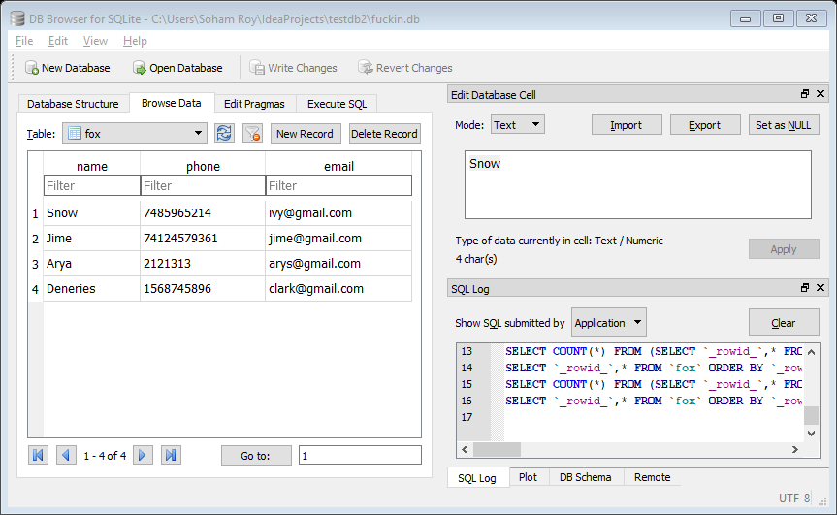

**Deletion**

**package** com.company;  
  
**import** java.sql.Connection;  
**import** java.sql.DriverManager;  
**import** java.sql.Statement;  
  
**public class** Main {  
  
 **public static void** main(String[] args) {  
 **try**{  
 Connection con = DriverManager.*getConnection*(**"jdbc:sqlite:C:\\Users\\Soham Roy\\IdeaProjects\\testdb2\\fuckin.db"**);  
*// con.setAutoCommit(false); RESISTS TO ADD THE VALUES IN THE TABLE* Statement statement = con.createStatement();  
 statement.execute(**"delete from fox where name = 'Snow'"**);  
 statement.close();  
 con.close();  
 } **catch** (Exception e) {  
 System.***out***.println(**"message : "** + e.getMessage());  
 }  
 }  
}

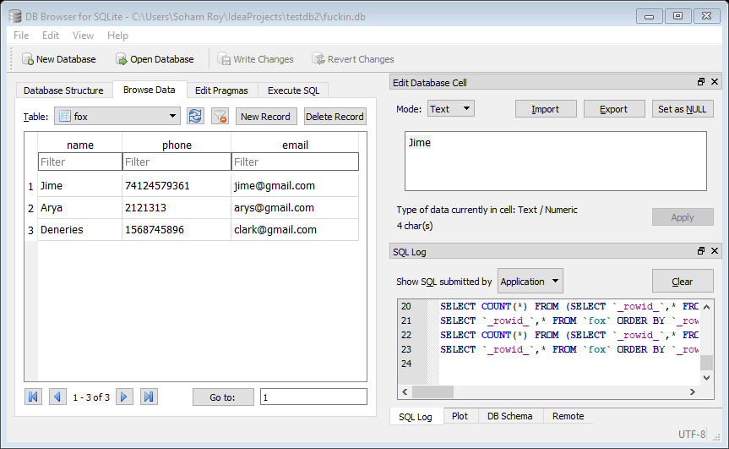

**Retrieving elements from database to console**

**package** com.company;  
  
**import** java.sql.Connection;  
**import** java.sql.DriverManager;  
**import** java.sql.ResultSet;  
**import** java.sql.Statement;  
  
**public class** Main {  
  
 **public static void** main(String[] args) {  
 **try**{  
 Connection con = DriverManager.*getConnection*(**"jdbc:sqlite:C:\\Users\\Soham Roy\\IdeaProjects\\testdb2\\fuckin.db"**);  
*// con.setAutoCommit(false); RESISTS TO ADD THE VALUES IN THE TABLE* Statement statement = con.createStatement();  
 statement.execute(**"select * from fox"**);  
 ResultSet r = statement.getResultSet();  
 **while** (r.next()){  
 System.***out***.println(r.getString(**"name"**) + **" | "** + r.getInt(**"phone"**) + **" | "** + r.getString(**"email"**));  
 }  
 statement.close();  
 con.close();  
 } **catch** (Exception e) {  
 System.***out***.println(**"message : "** + e.getMessage());  
 }  
 }  
}

**output:**

**Jime | 1110135329 | jime@gmail.com**

**Arya | 2121313 | arys@gmail.com**

**Deneries | 1568745896 |** [**clark@gmail.com**](mailto:clark@gmail.com)

**Retriving elements from database using no HARD CODES**

**package** com.company;  
**import** java.sql.*;  
**public class** Main {  
 **public static final** String ***DB_NAME*** = **"fuckin.db"**;  
 **public static final** String ***CONNECTION_STRING*** = **"jdbc:sqlite:C:\\Users\\Soham Roy\\IdeaProjects\\testdb2"** + ***DB_NAME***;  
  
 **public static final** String ***TABLE_CONTACTS*** = **"contacts"**;  
  
 **public static final** String ***COLUMN_NAME*** = **"name"**;  
 **public static final** String ***COLUMN_PHONE*** = **"phone"**;  
 **public static final** String ***COLUMN_EMAIL*** = **"email"**;  
  
 **public static void** main(String[] args) {  
 **try**{  
 Connection conn = DriverManager.*getConnection*(***CONNECTION_STRING***);  
 Statement statement = conn.createStatement();  
  
 statement.execute(**"DROP TABLE IF EXISTS "** + ***TABLE_CONTACTS***);  
  
 statement.execute(**"CREATE TABLE IF NOT EXISTS "** + ***TABLE_CONTACTS*** + **" ("** + ***COLUMN_NAME*** + **" text, "** + ***COLUMN_PHONE*** + **" integer, "** +  
 ***COLUMN_EMAIL*** + **" text"** + **")"**);  
  
 *insertContact*(statement,**"Tom"**, 6545678, **"tom@email.com"**);  
 *insertContact*(statement,**"Joe"**, 45632, **"joe@anywhere.com"**);  
 *insertContact*(statement,**"Jane"**, 4829484, **"jane@somewhere.com"**);  
 *insertContact*(statement,**"Fido"**, 9038, **"dog@email.com"**);  
  
 statement.execute(**"UPDATE "** + ***TABLE_CONTACTS*** + **" SET "** + ***COLUMN_PHONE*** + **"=5566789"** + **" WHERE "** + ***COLUMN_NAME*** + **"='Jane'"**);  
  
 statement.execute(**"DELETE FROM "** +***TABLE_CONTACTS*** + **" WHERE "** + ***COLUMN_NAME*** + **"='Joe'"**);  
  
 ResultSet results = statement.executeQuery(**"SELECT * FROM "** + ***TABLE_CONTACTS***);  
 **while**(results.next()) {  
 System.***out***.println(results.getString(***COLUMN_NAME***) + **" "** +  
 results.getInt(***COLUMN_PHONE***) + **" "** +  
 results.getString(***COLUMN_EMAIL***));  
 }  
  
 results.close();  
  
 statement.close();  
 conn.close();  
 } **catch** (Exception e) {  
 System.***out***.println(**"message : "** + e.getMessage());  
 }  
 }  
  
 **private static void** insertContact(Statement statement, String name, **int** phone, String email) **throws** SQLException {  
 statement.execute(**"INSERT INTO "** + ***TABLE_CONTACTS*** +**" ("** + ***COLUMN_NAME*** + **", "** + ***COLUMN_PHONE*** + **", "** + ***COLUMN_EMAIL*** + **" ) "** +  
 **"VALUES('"** + name + **"', "** + phone + **", '"** + email + **"')"**);  
 }  
}

**OUTPUT:**

**Tom 6545678 tom@email.com**

**Jane 5566789 jane@somewhere.com**

**Fido 9038 dog@email.com**